INFLATION MADE SIMPLE
A Google search of "inflation" on the first page highlighted a list of 3 main causes of inflation from Investopedia:

1) Demand-pull inflation, the upward pressure on prices that follows a shortage in supply.
2) Cost-plus inflation, when overall prices increase due to increases in the cost of wages and raw materials.
3) Built-in inflation, when workers expect their wages to increase when prices of goods and services increase.

And 5 more causes of inflation from Byjus.com:

1) Increase in wages,
2) Increase in the price of raw materials,
3) Increase in taxes,
4) Decline in productivity,
5) Increase in the money supply.

All of this is incredibly confusing, and it is designed to be so.

Demand-pull decline in productivity did happen at the peak of COVID due to draconian lock-downs and a 14.7% unemployment in April 2020, but it went down to 3.6% with no lock-downs, so demand-pull does not explain the persistently high inflation through 2022. (1)

Increase in personal taxes cannot increase inflation because that would cause less money able to be spent and less demand, but an increase in corporate taxes can decrease the supply of goods and services, causing increased demand. Trump reduced Federal corporate taxes from 35% to 21% in 2018, and it has remained there since. (2) Any other increase in taxes that may have occurred has not caused the present inflation.

Cost-plus and Built-in inflation with increased wages and the price of raw materials, goods, and services can only occur with an increase in the money supply. That is what has taken place. COVID gave Fauci and the government establishment the opportunity to shutdown the economy and increase reliance on government with lots of free money, free COVID tests, and free vaccines, a total of $4.2 trillion, about $11,000 per person according to usaspending.gov. That shutdown and vote buying frenzy started in 2020 with the Cares Act (Trump) and the American Rescue Plan (Biden). (3&4) That resulted in excessive deficit spending and is what has caused this present inflation. It was a huge mistake.

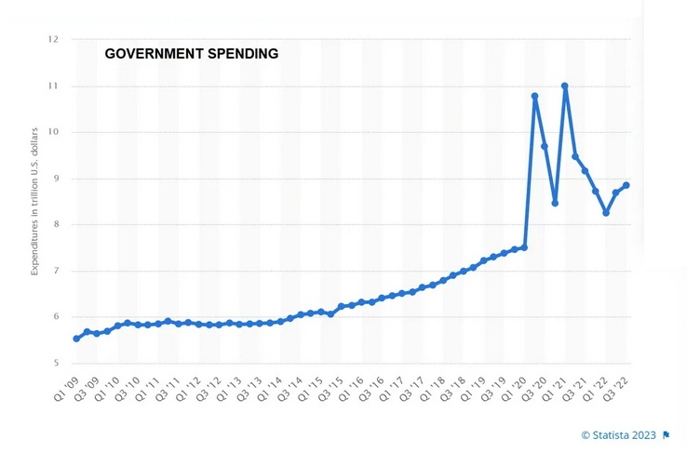

(4)

Since government spending is the major cause of inflation, how does the Federal Reserve decide to reduce it by raising interest rates? It makes no sense. Higher interest rates has never discouraged Federal government borrowing and spending. For example, from 2009 to 2015 the Federal Funds Rate was 0.13% and then rose by a factor of 16 to 2.18% with no decrease but actually a steadily increasing deficit spending. (5)

Inflation results when the Federal government spends more money than it takes in and the Federal Reserve makes it easy for the Federal government to borrow money to do that. The Fed does not print money for the loan because it does not have to. It can create the money with a mere keystroke ledger entry. (6) This spending expands the money supply resulting in more money competing for the same amount of goods and services. In order to reduce the supply of money, raising interest rates makes it more difficult for people to borrow money resulting in fewer loans while the monthly payments of previous loans reduce the supply of money. Monthly payments into the banking system would normally be the basis of new loans but not with high interest rates. Instead of requiring the Federal government to borrow less, you are discouraged from borrowing or punished if you do. Plus, with the “slowdown of the economy” and the inevitable recession and bank failures, everybody suffers especially those that loose their jobs. This is a swindle, a racket, and a fraud. This scam is a very sophisticated one because we are told constantly that we live in a free country, and most people believe it. But we actually have a system of economic enslavement. The Federal Reserve is a for-profit corporation and charging even a small amount of interest (1.6 to 2.1%) on 30 trillion dollars makes it the richest corporation in the world. The Fed is not working in your best interest and neither is the government establishment nor the administrative state.

Actually, the Federal Reserve did not have to raise interest rates to fight this inflation. There was no reason to cause further pain over and above the pain of inflation to attempt to lower inflation. According to the Fed’s own statistics, the currency expanded suddenly by 40% from January 2020 to February 2022. (9) When prices increase 40% then inflation will level off and return to a “normal” level. However, even a target of 2% per year is 20% every 10 years and is government sanctioned theft. (8)

Plus that 40% increase in prices is effectively a tax in addition the tax on your 1040 form. The government can borrow and spend money and you pay for it indirectly with what is similar to a sales tax only this time it is much larger and more destructive than the average 2%. Pretty clever and sneaky!

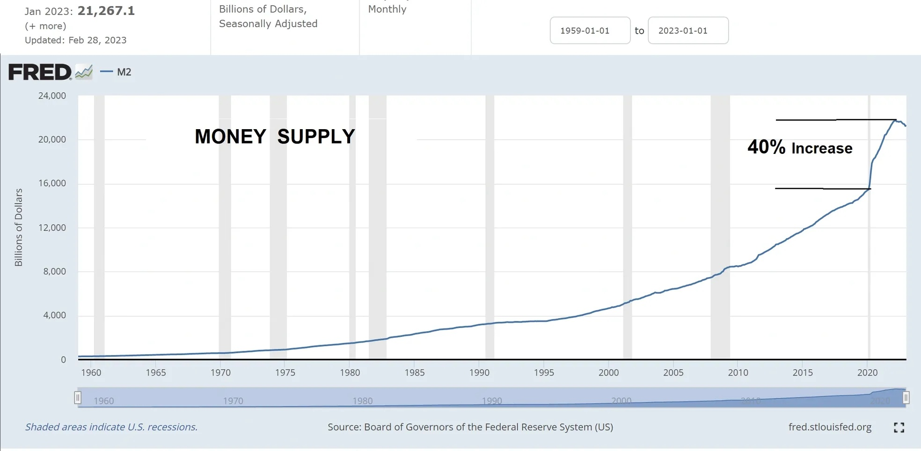
(9)

This corrupt economy especially affects the younger generations. According to Stanford.edu, children now have a less than 50% chance of earning a higher standard of living than their parents. The graph shows 45 years of decline!

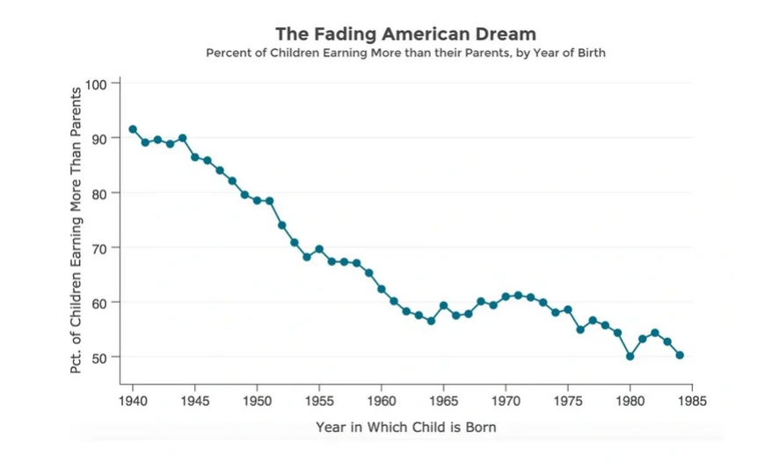

(7)

The consumer price index was stable for 138 years increasing less than 1% from 1775 to1913. After the Federal Reserve Act and the Income Tax Amendment were passed in 1913, prices increased dramatically up 3000% from 1913 to 2012. The national debt as of March, 2023 is $31.8 trillion, about $199,000 per taxpayer. (7) We are headed for economic disaster. This is not sustainable. The Federal Reserve makes huge profits from inflation and you are stuck with the perpetual interest payments on the National Debt along with continuously rising prices that outpace average incomes. In spite of advancing technology which results in increased productivity (more wealth produced per hour), the average person is falling behind.

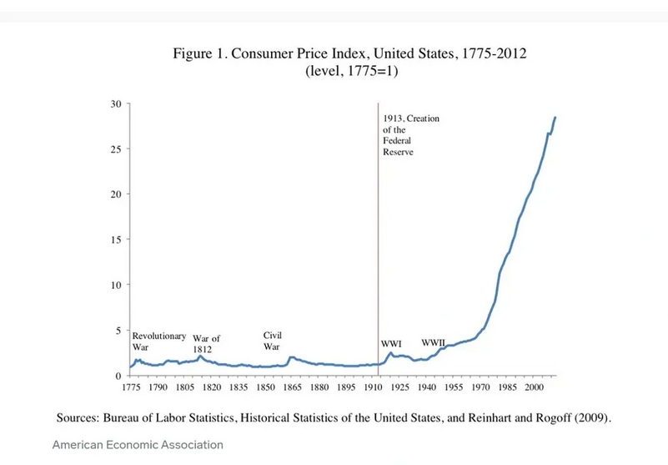

(10)

How bad is it? Just look at this. In the 70’s letters were made with typewriters, errors were corrected with whiteout, and copies were made with carbon paper. Computers were very primitive and expensive. Technology has increased dramatically and definitely made us more productive but hourly compensation has not kept up with increased productivity. I hate to tell you this but we do not live in a free country.

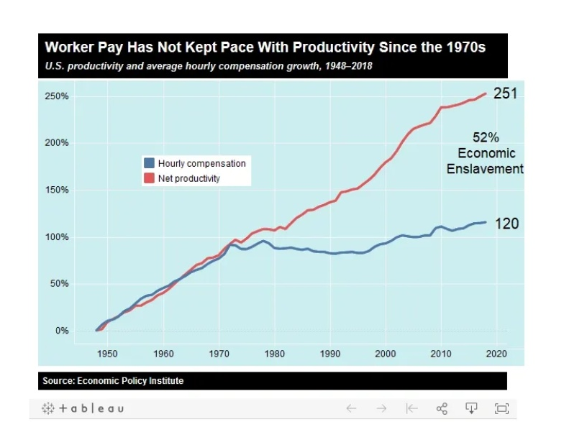

(11)

REFERENCES:

(1) https://ycharts.com/indicators/us_unemployment_rate Click the 5 year tab.
(2) https://tradingeconomics.com/united-states/corporate-tax-rate
(3) https://www.usaspending.gov/disaster/covid-19?publicLaw=all
(4) https://www.statista.com/statistics/215503/expenditures-of-the-us-government-by-quarter/
(5) https://www.bankrate.com/banking/federal-reserve/history-of-federal-funds-rate/
https://fiscaldata.treasury.gov/americas-finance-guide/national-deficit/
(6) https://theconversation.com/how-the-federal-reserve-literally-makes-money-140305
(7) https://www.businessinsider.com/chart-inflation-since-1775-2013-1
(8) https://www.usinflationcalculator.com/inflation/current-inflation-rates/
(9) https://fred.stlouisfed.org/series/M2SL
(10) https://inequality.stanford.edu/news-events/center-news/fading-american-dream
(11) https://www.orangejuiceblog.com/2012/05/a-key-chart-do-workers-share-in-economic-gains/

